WT – Assignment-2

Code

index.html
<!DOCTYPE html>
<html>
<head>
<title>Kshitij's Restaurant</title>
<link rel="stylesheet" href="styles.css">
</head>
<body>
<header style="background-color: #333; color: #fff; padding: 20px; text-align: center;">
<h1>Kshitij's Restaurant</h1>
</header>
<nav class="nav-menu">
<a href="#" style="color: #333; text-decoration: none; padding: 10px; margin: 5px;">Home</a>
<a href="#" style="color: #333; text-decoration: none; padding: 10px; margin: 5px;">Menu</a>
<a href="#" style="color: #333; text-decoration: none; padding: 10px; margin: 5px;">About</a>
<a href="#" style="color: #333; text-decoration: none; padding: 10px; margin: 5px;">Contact</a>
</nav>
<main>
<h2>Welcome to Kshitij's Restaurant</h2>
<p>We offer a wide variety of delicious dishes made with fresh, high-quality ingredients.</p>
<h2>Our Menu</h2>
<ul>
<li>Appetizers</li>
<li>Salads</li>
<li>Entrees</li>
<li>Desserts</li>
</ul>
<h2>About Us</h2>
<p>Our restaurant has been serving the community for over 10 years. We take pride in our commitment to providing excellent service and delicious food.</p>
<h2>Contact Us</h2>
<form>
<label for="name">Name:</label>
<input type="text" id="name" name="name" required>
<label for="email">Email:</label>
<input type="email" id="email" name="email" required>
<label for="message">Message:</label>
<textarea id="message" name="message" required></textarea>
<button type="submit">Send</button>
</form>
</main>
<footer style="background-color: #333; color: #fff; padding: 10px; text-align: center;">
<p>&copy; 2025 Kshitij's Restaurant. All rights reserved.</p>
</footer>
</body>
</html>

styles.css
body {
font-family: Arial, sans-serif;
margin: 0;
padding: 0;
}

.nav-menu {
background-color: #f2f2f2;
padding: 10px;
text-align: center;
}

.nav-menu a:hover {
background-color: #333;
color: #fff;
}

main {
padding: 20px;
}

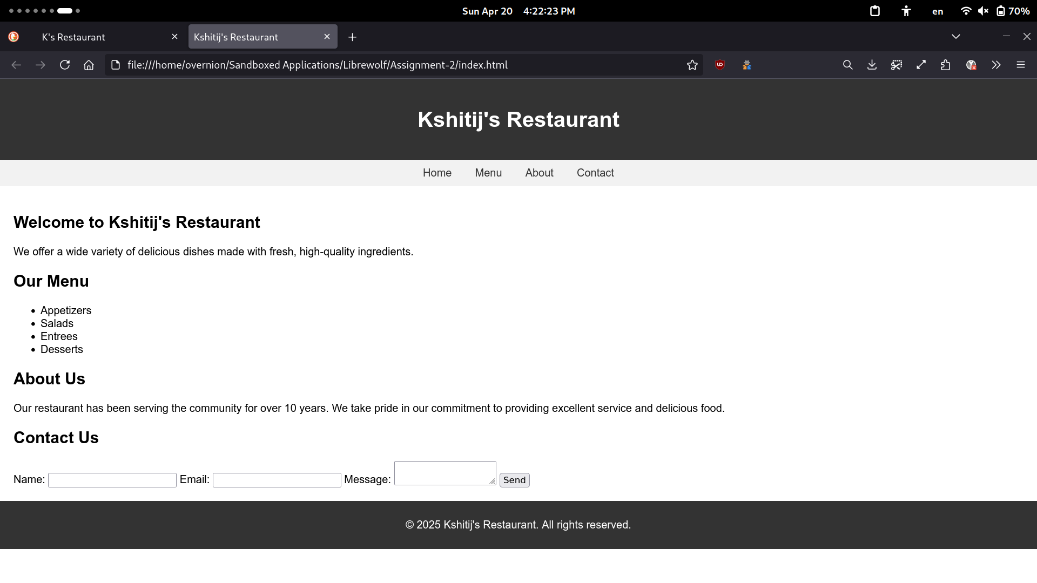
Output

