WT – Assignment-3

Code

employees.xml
<?xml version="1.0" encoding="UTF-8"?>
<?xml-stylesheet type="text/xsl" href="employees.xsl"?>
<employees>
<employee>
<id>1</id>
<name>Kshitij K</name>
<position>DevOps Engineer</position>
<department>IT</department>
<salary>6000000</salary>
</employee>
<employee>
<id>2</id>
<name>Ayush Kalas</name>
<position>Project Manager</position>
<department>IT</department>
<salary>8000</salary>
</employee>
<employee>
<id>3</id>
<name>Ombase</name>
<position>Frontend Developer</position>
<department>IT</department>
<salary>500</salary>
</employee>
</employees>

employees.xsl
<?xml version="1.0" encoding="UTF-8"?>
<xsl:stylesheet version="1.0" xmlns:xsl="http://www.w3.org/1999/XSL/Transform">
<xsl:template match="/">
<html>
<head>
<title>Employee List</title>
<style>
table {
width: 100%;
border-collapse: collapse;
}
th, td {
border: 1px solid black;
padding: 8px;
text-align: left;
}
th {
background-color: #f2f2f2;
}
</style>
</head>
<body>
<h2>Employee List</h2>
<table>
<tr>
<th>ID</th>
<th>Name</th>
<th>Position</th>
<th>Department</th>
<th>Salary</th>
</tr>
<xsl:for-each select="employees/employee">
<tr>
<td><xsl:value-of select="id"/></td>
<td><xsl:value-of select="name"/></td>
<td><xsl:value-of select="position"/></td>
<td><xsl:value-of select="department"/></td>
<td><xsl:value-of select="salary"/></td>
</tr>
</xsl:for-each>
</table>
</body>
</html>
</xsl:template>
</xsl:stylesheet>

employees.dtd
<!DOCTYPE employees [
<!ELEMENT employees (employee+)>
<!ELEMENT employee (id, name, position, department, salary)>
<!ELEMENT id (#PCDATA)>
<!ELEMENT name (#PCDATA)>
<!ELEMENT position (#PCDATA)>
<!ELEMENT department (#PCDATA)>
<!ELEMENT salary (#PCDATA)>
]>

employees.xsd
<?xml version="1.0" encoding="UTF-8"?>
<xs:schema xmlns:xs="http://www.w3.org/2001/XMLSchema">
<xs:element name="employees">
<xs:complexType>
<xs:sequence>
<xs:element name="employee" maxOccurs="unbounded">
<xs:complexType>
<xs:sequence>
<xs:element name="id" type="xs:integer"/>
<xs:element name="name" type="xs:string"/>
<xs:element name="position" type="xs:string"/>
<xs:element name="department" type="xs:string"/>
<xs:element name="salary" type="xs:decimal"/>
</xs:sequence>
</xs:complexType>
</xs:element>
</xs:sequence>
</xs:complexType>
</xs:element>
</xs:schema>

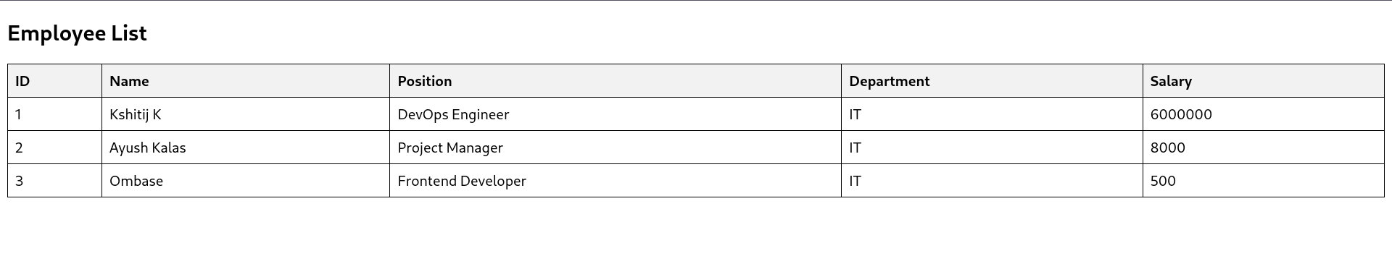
Output

