WT – Assignment-4

Code

index.html
<!DOCTYPE html>
<html>
<head>
<title>Calculator</title>
<link rel="stylesheet" href="styles.css">
</head>
<body>
<div class="calculator">
<h1>Calculator</h1>
<p class="designer">(Designed by Kshitij)</p>
<div class="display">
<input type="text" id="result" readonly>
</div>
<div class="buttons">
<button onclick="clearDisplay()">C</button>
<button onclick="calculate('/')">/</button>
<button onclick="calculate('*')">*</button>
<button onclick="calculate('-')">-</button>
<button onclick="addToDisplay('7')">7</button>
<button onclick="addToDisplay('8')">8</button>
<button onclick="addToDisplay('9')">9</button>
<button onclick="calculate('+')">+</button>
<button onclick="addToDisplay('4')">4</button>
<button onclick="addToDisplay('5')">5</button>
<button onclick="addToDisplay('6')">6</button>
<button onclick="calculate('=')">=</button>
<button onclick="addToDisplay('1')">1</button>
<button onclick="addToDisplay('2')">2</button>
<button onclick="addToDisplay('3')">3</button>
<button onclick="addToDisplay('0')">0</button>
<button onclick="addToDisplay('.')">.</button>
</div>
</div>
<script src="script.js"></script>
</body>
</html>

styles.css
body {
font-family: Arial, sans-serif;
display: flex;
justify-content: center;
align-items: center;
height: 100vh;
margin: 0;
background-color: #f0f0f0;
}

.calculator {
background-color: #fff;
padding: 20px;
border-radius: 5px;
box-shadow: 0 0 10px rgba(0, 0, 0, 0.1);
text-align: center;
}

.designer {
font-size: 14px;
color: #888;
margin-top: 5px;
}

.display {
margin-bottom: 10px;
}

.display input {
width: 100%;
font-size: 24px;
padding: 5px;
text-align: right;
border: 1px solid #ccc;
border-radius: 3px;
}

.buttons {
display: grid;
grid-template-columns: repeat(4, 1fr);
grid-gap: 5px;
}

.buttons button {
font-size: 18px;
padding: 10px;
background-color: #f0f0f0;
border: none;
border-radius: 3px;
cursor: pointer;
}

.buttons button:hover {
background-color: #e0e0e0;
}

script.js
let currentValue = '';

function addToDisplay(value) {
currentValue += value;
document.getElementById('result').value = currentValue;
}

function clearDisplay() {
currentValue = '';
document.getElementById('result').value = '';
}

function calculate(operator) {
if (operator === '=') {
try {
currentValue = eval(currentValue).toString();
document.getElementById('result').value = currentValue;
} catch (error) {
alert('Invalid expression');
clearDisplay();
}
} else {
if (currentValue === '') {
alert('Please enter a number');
return;
}
currentValue += operator;
document.getElementById('result').value = currentValue;
}
}

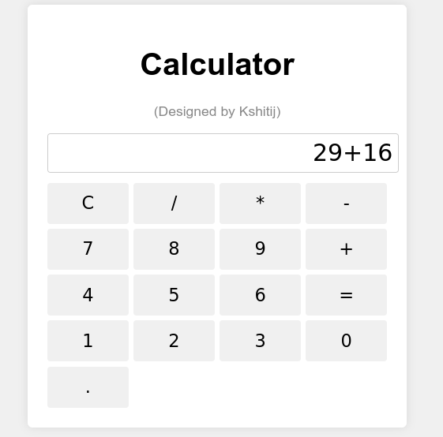
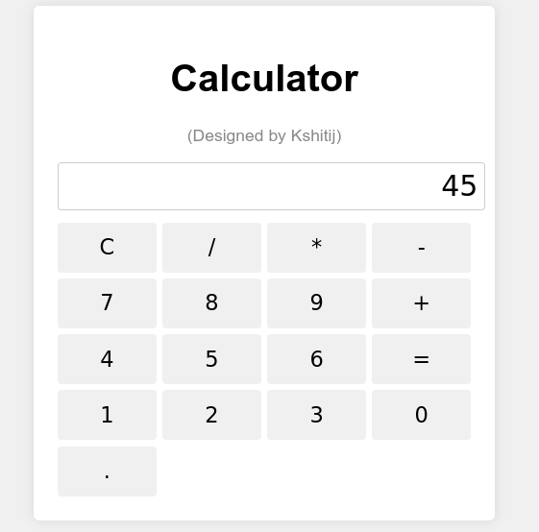
Output

