WT – Assignment-7

Code

dbconnect.php
<?php
// Database configuration
$host = 'localhost'; // MySQL server host
$dbname = 'connectivityDB'; // Database name
$username = 'kshitij'; // MySQL username
$password = 'Pass@123'; // MySQL password
try {
// Create a connection
$conn = new mysqli($host, $username, $password, $dbname);

// Check the connection
if ($conn->connect_error) {
throw new Exception("Connection failed: " . $conn->connect_error);
}
echo "Connected successfully<br>";
// CRUD Operations
// Create
function createUser($conn, $name, $email) {
$stmt = $conn->prepare("INSERT INTO users (name, email) VALUES (?, ?)");
$stmt->bind_param("ss", $name, $email);
if ($stmt->execute()) {
echo "New user created successfully<br>";
} else {
echo "Error: " . $stmt->error . "<br>";
}
$stmt->close();
}
// Read
function readUsers($conn) {
$result = $conn->query("SELECT * FROM users");
if ($result->num_rows > 0) {
while ($row = $result->fetch_assoc()) {
echo "ID: " . $row["id"] . " - Name: " . $row["name"] . " - Email: " . $row["email"] . "<br>";
}
} else {
echo "No users found.<br>";
}
}

// Update
function updateUser($conn, $id, $name, $email) {
$stmt = $conn->prepare("UPDATE users SET name = ?, email = ? WHERE id = ?");
$stmt->bind_param("ssi", $name, $email, $id);
if ($stmt->execute()) {
echo "User updated successfully<br>";
} else {
echo "Error: " . $stmt->error . "<br>";
}
$stmt->close();
}
// Delete
function deleteUser($conn, $id) {
$stmt = $conn->prepare("DELETE FROM users WHERE id = ?");
$stmt->bind_param("i", $id);
if ($stmt->execute()) {
echo "User deleted successfully<br>";
} else {
echo "Error: " . $stmt->error . "<br>";
}
$stmt->close();
}
// Example usage of CRUD operations
createUser($conn, "John Doe", "john@example.com");
createUser($conn, "Jane Smith", "jane@example.com");
echo "<br>All Users:<br>";
readUsers($conn);
updateUser($conn, 1, "John Updated", "john.updated@example.com"); // Update user with ID 1
echo "<br>All Users after update:<br>";
readUsers($conn);
deleteUser($conn, 2); // Delete user with ID 2
echo "<br>All Users after deletion:<br>";
readUsers($conn);
} catch (Exception $e) {
echo "Error: " . $e->getMessage();
} finally {
// Close the connection
if (isset($conn)) {
$conn->close();
}
}
?>

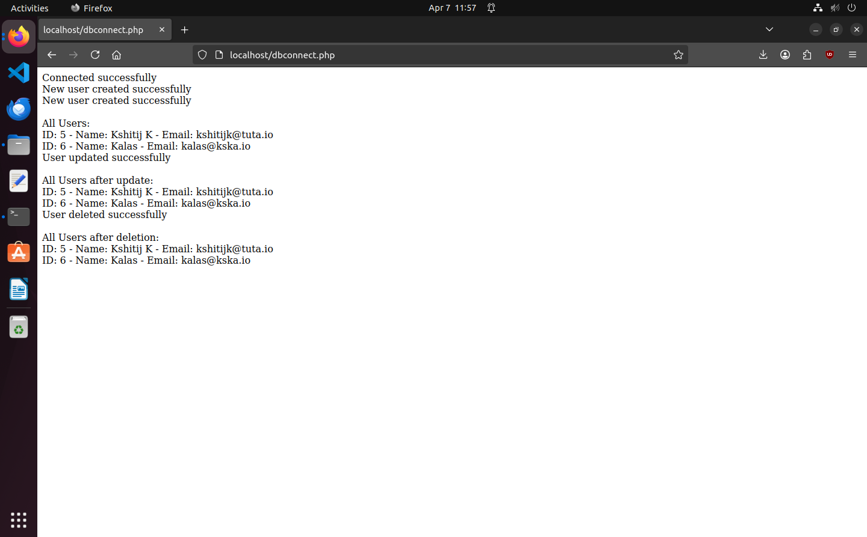
Output

